Final Project Design Phase
Computer Science - Week 11
Oct 3, 2026 - Version 0.0.4

For complete instructions and project ideas, refer to the assignment in Canvas. Specifically, review the final project requirements before you continue below. If you have not reviewed the project requirements in Canvas (you might have to go to the modules view and check the current or past week's content), you will not be able to properly complete the parts below. In addition, it may be helpful to review the information on this Drafter documentation page.

0) Project Planning and Preparation
Successful programmers spend time planning before they begin coding. After reviewing the project requirements, answer the following questions to help guide your design and development process.
- What concepts from class or previous assignments might help you complete this project? Which programming concepts (loops, conditionals, lists, classes, etc.) do you expect to use? What programming skills do you want to improve while completing this project?
I will need if statements, while loops, and other pieces to build functions that perform math functions based on logic. I want to get better at organizing a large program and understanding what eat part does.

- Which parts of the project do you expect to be the easiest for you? The hardest? Why?
The easiest part will be setting up the dataclass and getting the functions organized. The hardest part will be doing the iterative math to represent the amount of parts needed for each bridge configuration.

- Even though you have not yet designed the final project, estimate which tasks will likely require the most time and effort? Which features or components should be implemented first?
I think writing the individual functions will take the longest, because some of them will get complicated and I don’t know how to write all of those functions yet.

- What distractions might interfere with your work and how will you minimize them? What resources will you need available while working? What questions, if any, do you still have about the assignment requirements?
Other classes and personal life will have the biggest interference with my work. I will have the TA’s as a resource during office hours and the discord. I don’t have any questions right now about the project requirements.

1) Site Diagram
Create a mock-up of your planned website. We suggest you make the mockup on paper, although you can also use software like PowerPoint or Slides to make a mockup. There is other design software that could also be used, but we strongly encourage you to keep it simple. Do not spend more than 15-30 minutes detailing the mock-up. Your goal should be to make a very quick and dirty diagram, to show that you have some kind of idea.

We recommend drawing each page as a rectangle, and laying out the text, buttons, and other components inside. Then, use arrows to indicate links between pages. Label each page the way you will name each function, and then put labels on the arrows to indicate what the button links. Also write down any parameters that should come into the pages.

In addition to the pages and routes, write down what fields your `State` will have, both their names and types. Think clearly about what data will need to be persistent across the entire website.

Add photo(s) or screenshot(s) of your website mock-up and labeled diagram on the next page.
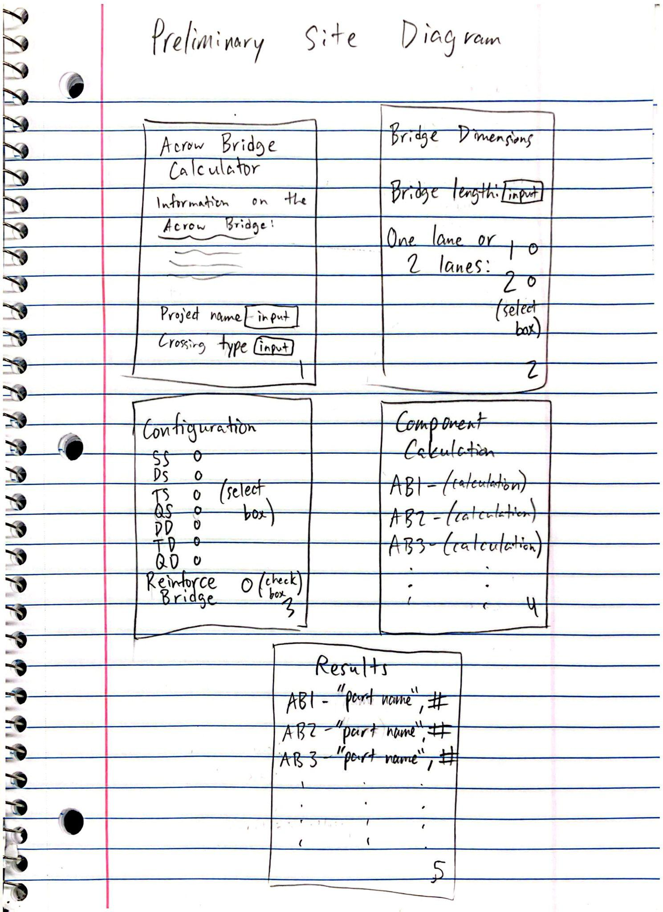

2) Implementing Requirements
This table should serve as a draft for how you will implement the requirements into your final project. You may change your ideas later on, but your final site must fulfill all the requirements.

Requirement | Implementation
Purpose/Functionality  A 1-2 sentence description of the purpose or functionality of your site | My program will perform calculations based on specifications and user input and output a specific list and number of parts needed to construct an Acrow bridge.
State Dataclass Attributes  Minimum of 4 attributes, one of which must be a list/dict of instances of your second dataclass.  Briefly describe each attribute, its type, and how it will be meaningfully modified throughout the site. | Bridge:  Width - str - “single” or “double”  Length - float - length of underpass  Reinforcement - bool - Y/N  Configuration - str - SS, DS, TS, QS, DD, TD, QD  Parts - list[Part]
Second Dataclass  Your second dataclass, including its attributes, their types, and how they will be meaningfully modified (if they are modified) | Part:  Name - str - name of part  Quantity - int - number of parts  Description - brief part description  Unit - str - measurement/size
Routes (minimum 7)  The names of your route functions | Home - home page  Get_bridge_width - user selects width  Get_bridge_length - user selects length  Get_configuration - user selects configuration  Get_reinforcement - user selects reinforcement  Calculate_parts - calculates # and type of parts  display_parts - displays final components
Pages (minimum 5)  A brief description of the pages in your site | Home page - Project setup, user input project name, crossing, etc.  Bridge dimensions - user inputs bridge length and width  Configuration section - user selects one of 7 configurations and reinforcement (y/n)  Component calculation - calculates total parts  Results - compiles calculations and data to list all materials and parts needed
User Input (minimum 3)  Description of user input components (TextBox, TextArea, CheckBox, or SelectBox) and their purposes  For more information on these input types, see Drafter Documentation. | Text box - bridge length  Select box - bridge width  Select box - bridge configuration  Check box - reinforced
If Statements (minimum 3)  Brief description of what will be evaluated in your if statements and how they will meaningfully change the logic of the site | Bridge length - If the entered length is less than or equal to zero, the program displays an error and requests a valid length.  Bridge width - If the user selects Single width, the program calculates components for a single-width bridge. Otherwise, it calculates components for a double-width bridge.  Bridge reinforcement - If the user selects reinforced, the program adds the necessary reinforcement components to the parts list.
Loop (minimum 1)  This loop must iterate over the list/dict of dataclass instances in your State attribute.  Description of this loop and why it is meaningful to the site | A for loop will be used to go through a list of component dataclasses. Each instance will contain information about a bridge component (name, quantity, dimensions, description)

LLM Conversation
If you used an LLM in any part of this work, copy and paste every part of that conversation below. Otherwise, you may be given a zero for the assignment. Obviously, these words will not all be yours, and this is the exception to the requirement at the top of this assignment that all responses be in your own words. If you did not use an LLM to assist you in this assignment, simply say so below.
did not use an LLM

Final Submission
When you are finished, download this file as a Word Document (docx) and upload the file to the appropriate assignment on Canvas.

